SAN BOIS CASA, INC.
KiBois Building 219 Kerr Avenue
P. O. Box 1392
Poteau, OK 74953
918-647-3267

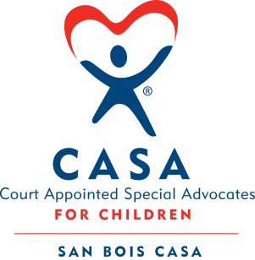

AGENDA

KiBois Community Action Center
April 11, 2024
4:00 p.m.

- Invocation

- Call to Order

- Roll Call (Compliance with Open Meeting Act)

- Welcome and Introduction of Guests

- Discussion and Possible Action on January 25, 2024 Minutes

- Discussion and Possible Action on Financial Review June 30, 2023

- Discussion and Possible Action on Accountant

- Executive Director’s Report – Quality Assurance OCASAA, Credit Card (Jan, Feb, & March 2024)

- Fundraising – Chad Yandell (Cajun Celebration & BBQ Fundraiser)

- Business not known within 24 hours of this meeting

- Adjournment

Next scheduled meeting
June 22, 2023

