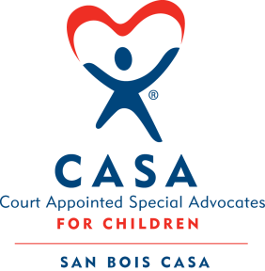
SAN BOIS CASA, INC.
KiBois Building 204 Wall
P. O. Box 1392
Poteau, OK 74953
918-647-3267

SPECIAL MEETING
AGENDA
KiBois Community Action Center
July 28, 2022 – 4:00 p.m.

- Invocation

- Call to Order

- Roll Call (Compliance with Open Meeting Act)

- Welcome and Introductions of Guests

- Discussion and Possible Action on June 16, 2022 Minutes

- Discussion and Possible Action on Financial Report for June 2022

- Discussion and Possible Action on Auditor for 2022

- Discussion and Possible Action on 2022-2023 Budget

IX. Business not known within 24 hours of this meeting

X. Adjournment

Next Meeting
September 15, 2022 – 4 p.m.

