SAN BOIS CASA, INC.
KiBois Building 219 Kerr Avenue
P. O. Box 1392
Poteau, OK 74953
918-647-3267

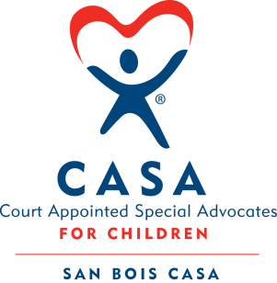

AGENDA

KiBois Community Action Center
June 16, 2026
4:00 p.m.

- Invocation

- Call to Order

- Roll Call (Compliance with Open Meeting Act)

- Welcome and Introduction of Guests

- Discussion and Possible Action on May 21, 2026 Minutes

- Discussion and Possible Action on Financial Report for May 2026

- Discussion and Possible Action on AI Policies for Program & Volunteers

- Discussion and Possible Action on Cybersecurity & Data Protection Policy & Procedures

- Discussion and Possible Action on Revised Job Descriptions

- Discussion and Possible Action on Goals & Objectives for FY ‘27

- Fundraising Report – 2026 Auction

- Executive Director’s Report – Credit Card (April 2026), Strategic Planning

XIII. Business not known within 24 hours of this meeting

XIV. Adjournment

Next scheduled meeting
August 20, 2026

