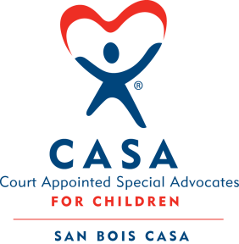
SAN BOIS CASA, INC.
KiBois Building 204 Wall St.
P. O. Box 1392
Poteau, OK 74953
918-647-3267

AGENDA

KiBois Community Action Center
June 16, 2022 – 4:00 p.m.

- Invocation

- Call to Order

- Roll Call (Compliance with Open Meeting Act)

- Welcome and Introductions of Guests

- Discussion and Possible Action on March 24, 2022 Minutes

- Discussion and Possible Action on Financial Reports for March, April, and May 2022

- Discussion and Possible Action on Goals & Objectives for 2022-2023

- Discussion and Possible Action on Communication and Marketing Plan FY 2022

- Fundraising Reports – Chad Yandell and Justin Kennedy

- Potential Board Member – Justin Kennedy

- Director’s Report – Credit Card Purchases (March & April 2022), Budget Projections 2022-2023

XII. Business not known within 24 hours of this meeting

XIII. Adjournment

Next Meeting
September 15, 2022 – 4:00 p.m.

