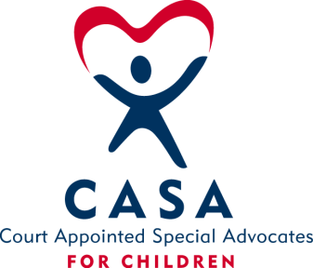
SAN BOIS CASA, INC.
KiBois Building – 219 Kerr Avenue
P. O. Box 1392
Poteau, OK 74953
918-647-3267

AGENDA

KiBois Community Action Center
December 13, 2023

- Invocation

- Call to Order

- Roll Call (Compliance with Open Meeting Act)

- Welcome and Introductions of Guests – Brandi Way, New Advocate Supervisor

- Discussion and Possible Action on August 17, 2023 Minutes

VI. Discussion and Possible Action on Financial Reports for August, September, & October

VII. Discussion and Possible Action on 2024 Board Meeting Dates

VIII. Discussion and Possible Action on 2023-2024 Revised Budget

IX. Director’s Report – Credit Card (Aug, Sept, Oct. & Nov. 2023), Golf Tournament & Superhero Run

X. Business not known within 24 hours of this meeting

XI. Adjournment

Next Meeting
January 18, 2024

