SAN BOIS CASA, INC.
KiBois Building 204 Wall Street
P. O. Box 1392
Poteau, OK 74953
918-647-3267

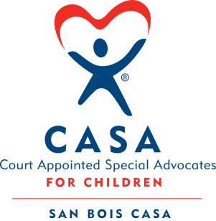

AGENDA

KiBois Community Action Center
March 23, 2023
4:00 p.m.

- Invocation

- Call to Order

- Roll Call (Compliance with Open Meeting Act)

- Welcome and Introduction of Guests

- Discussion and Possible Action on February 23, 2022 Minutes

- Discussion and Possible Action on Financial Report for January 2023

- Discussion and Possible Action on Updating Signatures on Bank Card

- Discussion and Possible Action on Chamber Memberships

- Executive Director’s Report – Credit Card (Dec 2022 & Jan 2023)

- Fundraising – Chad Yandell & Justin Kennedy

- Business not known within 24 hours of this meeting

- Adjournment

Next scheduled meeting
June 22, 2023

