SAN BOIS CASA, INC.
KiBois Building 204 Wall Street
P. O. Box 1392
Poteau, OK 74953
918-647-3267

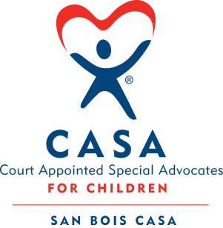

AGENDA

KiBois Community Action Center
December 12, 2019
4:00 p.m.

- Invocation

- Call to Order

- Roll Call (Compliance with Open Meeting Act)

- Welcome and Introduction of Guests

- Discussion and Possible Action on November 14, 2019 Minutes

- Discussion and Possible Action on Financial Report for November 2019

- Discussion and Possible Action on 2020 Board Meeting Dates

- Discussion and Possible Action on Limited English Proficiency Policy

- Director’s Report – Credit Card Purchases, OCASAA Site Visit, Golf Tournament

X. Business not known within 24 hours of this meeting

XI. Adjournment

Next scheduled meeting
January 16, 2020

