SAN BOIS CASA, INC.
KiBois Building 204 Wall Street
P. O. Box 1392
Poteau, OK 74953
918-647-3267

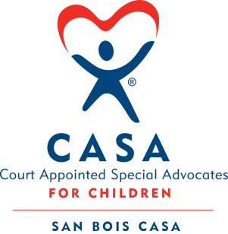

AGENDA

KiBois Community Action Center
January 21, 2021
4:00 p.m.

- Invocation

- Call to Order

- Roll Call (Compliance with Open Meeting Act)

- Welcome and Introduction of Guests

- Discussion and Possible Action on December 17, 2020 Minutes

- Discussion and Possible Action on Financial Report for December 2020

- Executive Director’s Report – Credit Card (Nov. & Dec.), VOCA Site Visit

VIII. Advocate Supervisor’s Report – Pre-Service Trainings

IX. Business not known within 24 hours of this meeting

X. Adjournment

Next scheduled meeting
March 25, 2021

