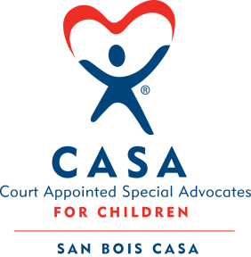
SAN BOIS CASA, INC.
KiBois Building 219 Kerr Ave
P. O. Box 1392
Poteau, OK 74953
918-647-3267

AGENDA

KiBois Community Action Center
December 18, 2025 – 4:00 p.m.

- Invocation

- Call to Order

- Roll Call (Compliance with Open Meeting Act)

- Welcome and Introductions of Guests

- Discussion and Possible Action on October 21, 2025 Minutes

- Discussion and Possible Action on Financial Reports for September, October, & November 2025

- Discussion and Possible Action on Financial Review Ending June 30, 2025

- Discussion and Possible Action on Adding Gary Jordan on Bank Card

- Executive Director’s Report – Credit Card Purchases (September & October 2025), Superhero Run Fundraiser, Dates for 2026 Fundraisers

- Business Not Known Within 24 Hours of This Meeting

- Adjournment

Next Meeting
January 15, 2026 – 4:00 p.m.

