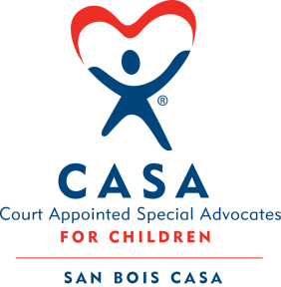
SAN BOIS CASA, INC.
KiBois Building 219 Kerr Ave
P. O. Box 1392
Poteau, OK 74953
918-647-3267

AGENDA

KiBois Community Action Center
September 18, 2025 – 4:00 p.m.

- Invocation

- Call to Order

- Roll Call (Compliance with Open Meeting Act)

- Welcome and Introductions of Guests

- Discussion and Possible Action on July 8, 2025 Minutes

- Discussion and Possible Action on Financial Reports for June, July, & August 2025

- Discussion and Possible Action on Board of Directors Committees

- Fundraising Report – CASA Superhero Run

- Executive Director’s Report – Credit Card Purchases (July & August 2025)

- Business not known within 24 hours of this meeting

- Adjournment

Next Meeting
October 23, 2025 – 4:00 p.m.

