SAN BOIS CASA, INC.
KiBois Building 219 Kerr Avenue
P. O. Box 1392
Poteau, OK 74953
918-647-3267

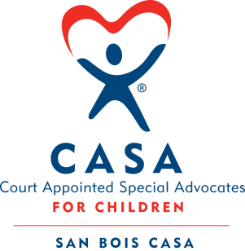

AGENDA

KiBois Community Action Center
January 15, 2026
4:00 p.m.

- Invocation

- Call to Order

- Roll Call (Compliance with Open Meeting Act)

- Welcome and Introduction of Guests

- Discussion and Possible Action on December 18, 2025 Minutes

- Discussion and Possible Action on Financial Report for December 2025

- Discussion and Possible Action on 990 Taxes

- Fundraising Report – Fat Tuesday Cajun Celebration, Golf Tournament

- Executive Director’s Report – Credit Card (November)

XIII. Business not known within 24 hours of this meeting

XIV. Adjournment

Next scheduled meeting
March 26, 2026

