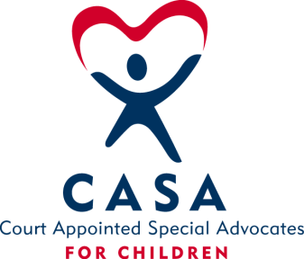
SAN BOIS CASA, INC.
KiBois Building - 204 Wall St.
P. O. Box 1392
Poteau, OK 74953
918-647-3267

AGENDA

KiBois Community Action Center
December 15, 2022

- Invocation

- Call to Order

- Roll Call (Compliance with Open Meeting Act)

- Welcome and Introductions of Guests – Amanda Grant, Potential Board Member & Tristian McCool, New Advocate Supervisor

- Discussion and Possible Action on September 22, 2022 Minutes

VI. Discussion and Possible Action on Financial Reports for September & October 2022

VII. Discussion and Possible Action on 2023 Board Meeting Dates

VIII. Discussion and Possible Action on Resignation of Sarah Jordan, President

IX. Discussion and Possible Action on Filling Vacant Board Positions

X. Discussion and Possible Action for New Board Member, Amanda Grant

XI. Director’s Report – Credit Card (Aug, Sept, & Oct. 2022), Harness Online Donations, CASA Superhero Run

XII. Business not known within 24 hours of this meeting

XIII. Adjournment

Next Meeting
February 16, 2023

