SAN BOIS CASA, INC.
KiBois Building 204 Wall Street
P. O. Box 1392
Poteau, OK 74953
918-647-3267

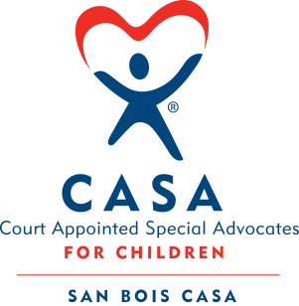

AGENDA

KiBois Community Action Center
February 23, 2023
4:00 p.m.

- Invocation

- Call to Order

- Roll Call (Compliance with Open Meeting Act)

- Welcome and Introduction of Guests

- Discussion and Possible Action on December 15, 2022 Minutes

- Discussion and Possible Action on Financial Report for November & December 2022

- Discussion and Possible Action on Financial Review ending June 30, 2022

- Discussion and Possible Action on Board of Directors Committees

- Discussion and Possible Action on 2021 990-EZ

- Discussion and Possible Action on Strategic Plan 2023-2026

- Executive Director’s Report – Credit Card (Nov. & Dec), Cajun Celebration Fundraiser

XII. Business not known within 24 hours of this meeting

XIII. Adjournment

Next scheduled meeting
March 23, 2023

