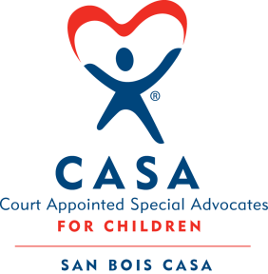
SAN BOIS CASA, INC.
KiBois Building 204 Wall St.
P. O. Box 1392
Poteau, OK 74953
918-647-3267

AGENDA

KiBois Community Action Center
June 13, 2019 – 4:00 p.m.

- Invocation

- Call to Order

- Roll Call (Compliance with Open Meeting Act)

- Welcome and Introductions of Guests

- Discussion and Possible Action on April 11, 2019 Minutes

- Discussion and Possible Action on April 25, 2019 Minutes

- Discussion and Possible Action on Financial Report for April 2019

- Discussion and Possible Action on Financial Report for May 2019

- Election of Officers for New Year and Committee Assignments

- Director’s Report – Approve Credit Card Purchases

- Discussion and Possible Action on Resignation of Jalynn Youngberg, Interim Executive Director

- Discussion and Vote to Enter Executive Session pursuant to 25 O.S. § 307(B)(1)1

- Vote to Return to Open Meeting

- Discussion and Possible Action on Hiring new Interim Director

XV. Business not known within 24 hours of this meeting

XVI. Adjournment

Next Meeting
August 8, 2019 – 4:00 p.m.

