SAN BOIS CASA, INC.
KiBois Building 219 Kerr Avenue
P. O. Box 1392
Poteau, OK 74953
918-647-3267

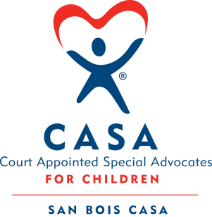

AGENDA

KiBois Community Action Center
March 25, 2026
4:00 p.m.

- Invocation

- Call to Order

- Roll Call (Compliance with Open Meeting Act)

- Welcome and Introduction of Guests

- Discussion and Possible Action on January 15, 2026 Minutes

- Discussion and Possible Action on Financial Reports for January & February 2026

- Discussion and Possible Action on Revised Mission Statement

- Fundraising Report – Fat Tuesday Cajun Celebration, Golf Tournament, BBQ

- Executive Director’s Report – Credit Card (December 2025, January 2026)

XIII. Business not known within 24 hours of this meeting

XIV. Adjournment

Next scheduled meeting
May 21, 2026

