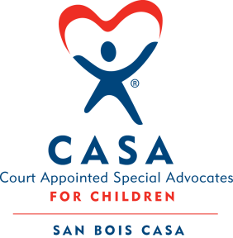
SAN BOIS CASA, INC.
KiBois Building 204 Wall St.
P. O. Box 1392
Poteau, OK 74953
918-647-3267

AGENDA

KiBois Community Action Center
September 16, 2021 – 4:00 p.m.

- Invocation

- Call to Order

- Roll Call (Compliance with Open Meeting Act)

- Welcome and Introductions of Guests – Alexa Mutz

- Discussion and Possible Action on July 15, 2021 Minutes

- Discussion and Possible Action on Financial Reports for June and July 2021

- Discussion and Possible Action on Board Committees

- Discussion and Possible Action on Revised PII Confidentiality Breach Policy

- Director’s Report – Credit Card Purchases (May, June, July), VOCA, Golf Tournament, New Volunteer Training

X. Business not known within 24 hours of this meeting

XI. Adjournment

Next Meeting
December 16, 2021 – 4:00 p.m.

