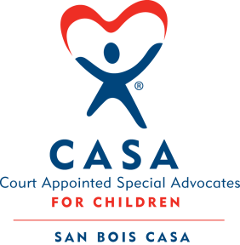
SAN BOIS CASA, INC.
KiBois Building 204 Wall St.
P. O. Box 1392
Poteau, OK 74953
918-647-3267

AGENDA

KiBois Community Action Center
August 17, 2023 – 4:00 p.m.

- Invocation

- Call to Order

- Roll Call (Compliance with Open Meeting Act)

- Welcome and Introductions of Guests

- Discussion and Possible Action on June 22, 2023 Minutes

- Discussion and Possible Action on Financial Reports for May, June & July 2023

- Discussion and Possible Action on FY’24 Proposed Budget

- Fundraising Reports – Golf Tournament & CASA Superhero Run

- Director’s Report – VOCA Grant, Advocate Supervisor Position, Credit Card Purchases (May, June, & July 2023)

X. Business not known within 24 hours of this meeting

XI. Adjournment

Next Meeting
September 21, 2023 – 4:00 p.m.

