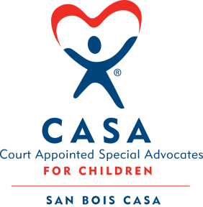
SAN BOIS CASA, INC.
KiBois Building 219 Kerr Ave
P. O. Box 1392
Poteau, OK 74953
918-647-3267

AGENDA

KiBois Community Action Center
October 21, 2025 – 4:00 p.m.

- Invocation

- Call to Order

- Roll Call (Compliance with Open Meeting Act)

- Welcome and Introductions of Guests

- Discussion and Possible Action on September 18, 2025 Minutes

- Discussion and Possible Action on Financial Report for September 2025

- Discussion and Possible Action on Revised 2025-2026 Budget

- Discussion and Possible Action on Board Meeting Dates for 2026

- Discussion and Possible Action on PMT Policy for VOCA Grant

- Executive Director’s Report – Credit Card Purchases (September 2025), IOLTA Grant

XI. Business not known within 24 hours of this meeting

XII. Adjournment

Next Meeting
December 18, 2025 – 4:00 p.m.

