**SAN BOIS *CASA*, INC.**

KiBois Building 219 Kerr Avenue

P. O. Box 1392

Poteau, OK 74953

918-647-3267

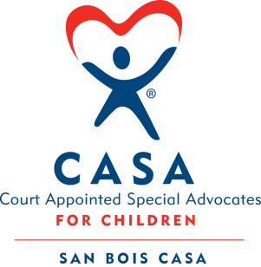

**AGENDA**

KiBois Community Action Center

July 8, 2025

4:00 p.m.

1. Invocation
2. Call to Order
3. Roll Call (Compliance with Open Meeting Act)
4. Welcome and Introduction of Guests
5. Discussion and Possible Action on May 22, 2025 Minutes
6. Discussion and Possible Action on Financial Reports for April & May 2025
7. Discussion and Possible Action on Goals and Objectives for FY’26
8. Discussion and Possible Action on Proposed Budget for FY’26
9. Fundraising Report – Auction – Justin Kennedy
10. Executive Director’s Report – Credit Card (May & June 2025)

XI. Business not known within 24 hours of this meeting

XII. Adjournment

Next scheduled meeting

September 18, 2025