SAN BOIS CASA, INC.
KiBois Building 204 Wall Street
P. O. Box 1392
Poteau, OK 74953
918-647-3267

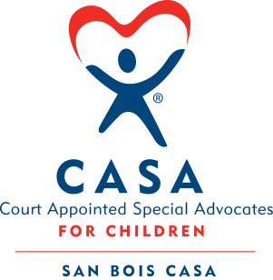

AGENDA

KiBois Community Action Center
March 24, 2022
4:00 p.m.

- Invocation

- Call to Order

- Roll Call (Compliance with Open Meeting Act)

- Welcome and Introduction of Guests

- Discussion and Possible Action on February 17, 2022 Minutes

- Discussion and Possible Action on Financial Report for February 2022

- Discussion and Possible Action to Expand into Coal County

- Discussion and Possible Action on 2021 Audit

- Discussion and Possible Action on 990-EZ for 2020

- Discussion and Possible Action on Diversity Plan 2023-2025

- Executive Director’s Report – Credit Card (Jan. & Feb.)

- Fundraising – Chad Yandell

- Business not known within 24 hours of this meeting

- Adjournment

Next scheduled meeting
June 16, 2022

