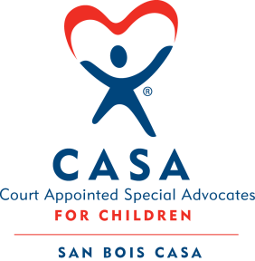
SAN BOIS CASA, INC.
KiBois Building 204 Wall St.
P. O. Box 1392
Poteau, OK 74953
918-647-3267

AGENDA

KiBois Community Action Center
June 22, 2023 – 4:00 p.m.

- Invocation

- Call to Order

- Roll Call (Compliance with Open Meeting Act)

- Welcome and Introductions of Guests

- Discussion and Possible Action on March 23, 2023 Minutes

- Discussion and Possible Action on Financial Reports for February, March, & April 2023

- Discussion and Possible Action on 2022 Audit or Financial Review

- Discussion and Possible Action on Goals and Objectives for 2023-2024

- Discussion and Possible Action on FY’24 Proposed Budget

- Fundraising Reports – Chad Yandell and Justin Kennedy

- Director’s Report – ARPA Grant, Credit Card Purchases (February, March, & April 2023), Golf Tournament, CASA Superhero Run

XI. Business not known within 24 hours of this meeting

XII. Adjournment

Next Meeting
August 17, 2023 – 4:00 p.m.

