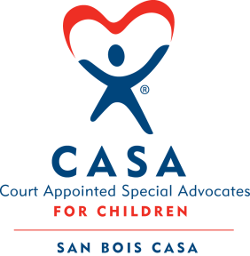
SAN BOIS CASA, INC.
KiBois Building 204 Wall St.
P. O. Box 1392
Poteau, OK 74953
918-647-3267

AGENDA

KiBois Community Action Center
September 12, 2019 – 4:00 p.m.

- Invocation

- Call to Order

- Roll Call (Compliance with Open Meeting Act)

- Welcome and Introductions of Guests

- Discussion and Possible Action on June 13, 2019 Minutes

- Discussion and Possible Action on Financial Report for June 2019

- Discussion and Possible Action on Financial Report for July 2019

- Discussion and Possible Action on 2019-2020 Proposed Budget

- Discussion and Possible Action on Resignation of Debbie Williams

- Discussion and Possible Action on 2019-2020 Board Committee Assignments

- Discussion and Possible Action on Pittsburg County Office

- Director’s Report – Credit Card Report, VOCA Grant, Golf Tournament Fundraiser

- Advocate Supervisor’s Report – Volunteer Training

XIV. Business not known within 24 hours of this meeting

XV. Adjournment

Next Meeting
November 14, 2019 – 4:00 p.m.

