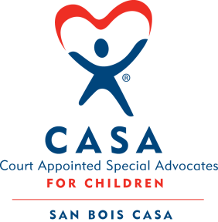
SAN BOIS CASA, INC.
KiBois Building 204 Wall
P. O. Box 1392
Poteau, OK 74953
918-647-3267

SPECIAL MEETING
AGENDA
KiBois Community Action Center
July 15, 2021 – 4:00 p.m.

- Invocation

- Call to Order

- Roll Call (Compliance with Open Meeting Act)

- Welcome and Introductions of Guests

- Discussion and Possible Action on June 17, 2021 Minutes

- Discussion and Possible Action on 2021-2022 Budget

- Discussion and Possible Action on Goals and Objectives 2021-2022 OCASAA Grant

- Discussion and Possible Action on Removal of Steven Sockey as Director & VP

- Discussion and Possible Action on Vice President for Board of Directors

X. Business not known within 24 hours of this meeting

XI. Adjournment

Next Meeting
September 16, 2021 – 4 p.m.

