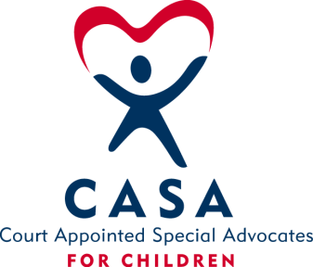
SAN BOIS CASA, INC.
KiBois Building - 204 Wall St.
P. O. Box 1392
Poteau, OK 74953
918-647-3267

AGENDA

KiBois Community Action Center
December 16, 2021

- Invocation

- Call to Order

- Roll Call (Compliance with Open Meeting Act)

- Welcome and Introductions of Guests

- Discussion and Possible Action on September 16, 2021 Minutes

VI. Discussion and Possible Action on Financial Reports for August, September, and October 2021

VII. Discussion and Possible Action on 2022 Board Meeting Dates

VIII. Discussion and Possible Action on 2021-2022 Budget

IX. Director’s Report – Credit Card (Aug, Sept, & Oct. 2021), OCASAA Grants

XIV. Business not known within 24 hours of this meeting

XV. Adjournment

Next Meeting
January 20, 2022

