**SAN BOIS *CASA*, INC.**

KiBois Building 219 Kerr Avenue

P. O. Box 1392

Poteau, OK 74953

918-647-3267

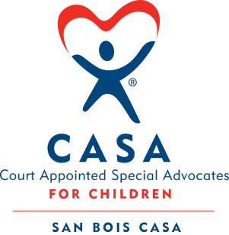

**AGENDA**

KiBois Community Action Center

May 22, 2025

4:00 p.m.

1. Invocation
2. Call to Order
3. Roll Call (Compliance with Open Meeting Act)
4. Welcome and Introduction of Guests
5. Discussion and Possible Action on February 20, 2025 Minutes
6. Discussion and Possible Action on Financial Reports for January, February, March 2025
7. Discussion and Possible Action on Weapons Policy
8. Discussion and Possible Action of Review Engagement for Year Ending June 30, 2025
9. Fundraising Report – Fat Tuesday Fundraiser, BBQ Fundraiser, Rough Day Fun Run; Future Event - 2025 Auction – Justin Kennedy
10. Executive Director’s Report – Credit Card (February, March, April 2025), National CASA Grant, SB 600

XI. Business not known within 24 hours of this meeting

XII. Adjournment

Next scheduled meeting

July 17, 2025