SAN BOIS CASA, INC.
KiBois Building 204 Wall Street
P. O. Box 1392
Poteau, OK 74953
918-647-3267

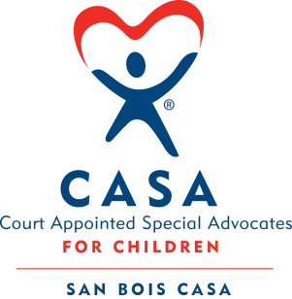

AGENDA

KiBois Community Action Center
December 20, 2018
4:00 p.m.

- Invocation

- Call to Order

- Roll Call (Compliance with Open Meeting Act)

- Welcome and Introduction of Guests

- Discussion and Possible Action on November 8, 2018 Minutes

- Discussion and Possible Action on Financial Report for November 2018

- Discussion and Possible Action on 2019 Board Meeting Dates

- Director’s Report – Credit Card Purchases

- Advocate Coordinator’s Report – Children Served 2017/2018

X. Business not known within 24 hours of this meeting

XI. Adjournment

Next scheduled meeting
January 10, 2019

