SAN BOIS CASA, INC.
KiBois Building 219 Kerr Avenue
P. O. Box 1392
Poteau, OK 74953
918-647-3267

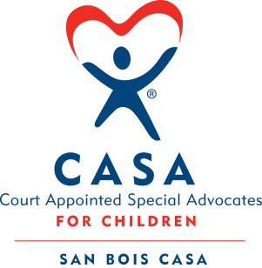

AGENDA

KiBois Community Action Center
January 25, 2024
4:00 p.m.

- Invocation

- Call to Order

- Roll Call (Compliance with Open Meeting Act)

- Welcome and Introduction of Guests

- Discussion and Possible Action on December 13, 2023 Minutes

- Discussion and Possible Action on Financial Report for November 2023

- Fundraising Report – Cajun Celebration 2024, BBQ Fundraiser

- Executive Director’s Report – Credit Card (December 2023), Children Served

IX. Business not known within 24 hours of this meeting

X. Adjournment

Next scheduled meeting
April 11, 2024

