SAN BOIS CASA, INC.
KiBois Building 204 Wall Street
P. O. Box 1392
Poteau, OK 74953
918-647-3267

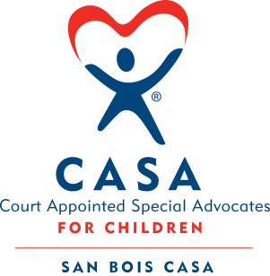

AGENDA

McAlester Office, 216 E. Choctaw
February 20, 2020
4:00 p.m.

- Invocation

- Call to Order

- Roll Call (Compliance with Open Meeting Act)

- Welcome and Introduction of Guests

- Discussion and Possible Action on January 16, 2020 Minutes

- Discussion and Possible Action on Financial Report for January

- Discussion and Possible Action on the 2019 Audit

- Executive Director’s Report – Billboard, Bylaws & Governance Policies

IX. Business not known within 24 hours of this meeting

X. Adjournment

Next scheduled meeting
March 10, 2016

